Table of Contents
User Guide 2
About the program 2
System requirement 2
Consumer user guide 2
How to see available item to add to chart 2
how to add products to chart and check quantity 2
how to Print invoice 3
Administrator user guide 4
How to login as an admin 4
how do to check products available in the store’s database 5
how to add products in the store 5
how to update products in the store 6
how to remove stock in the store 6

User Guide

About the program
This is a GUI System developed specifically for business that sell food products and allowing administrator to make changes in the stock system, the program interacts with the systems database

Consumer user guide

How to see available item to add to chart
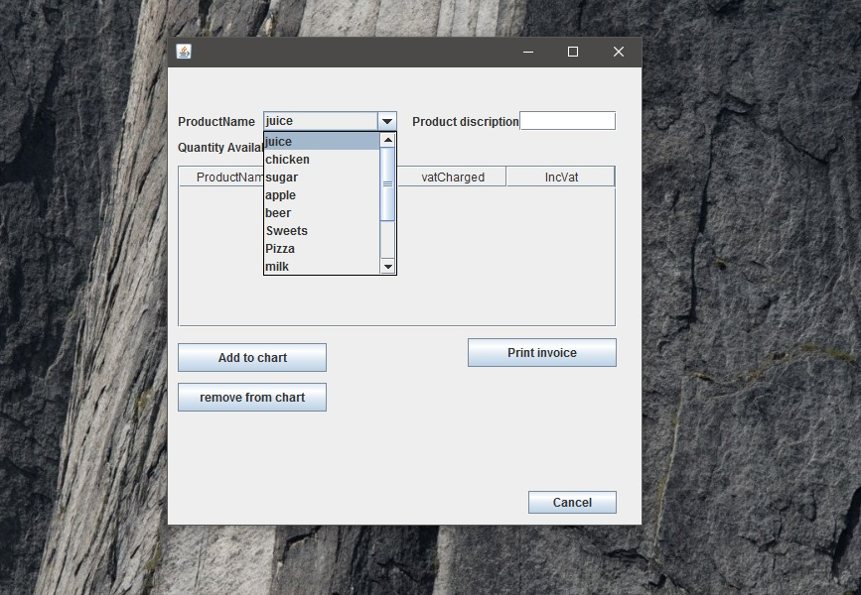

To add an item to your shopping list, tap on the search Combo-box to view items available in the Shop You can quickly scroll down on this drop down list by holding the blue scroll bar and moving it up and down as shown in the screen shot below or you can use the text-field and Write in the Name of the product, below the table "ADD TO CHART” button located at the Centre left of the view

how to Print invoice
Now you can either continue adding more items or just tap on the "Print invoice" button at the bottom so that it can show you the sub total of the items bought including Vat
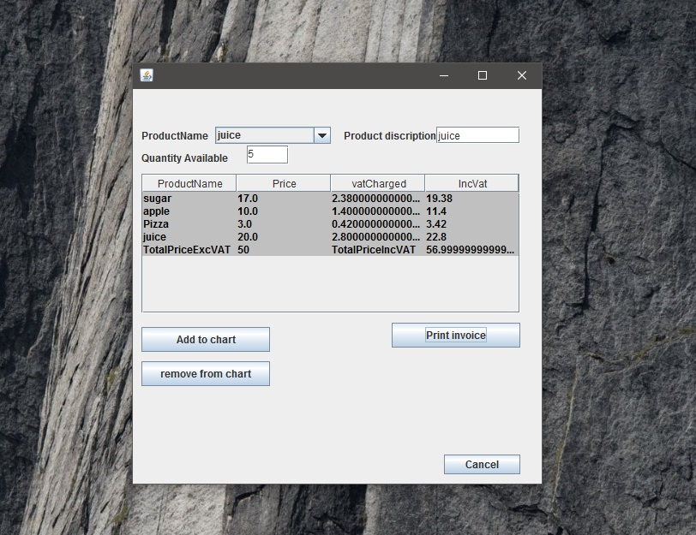

so, the Print invoice will change the table as seen above to a way that a user sees
how much each item cost and the subtotal without tax and with tax

Administrator user guide

How to login as an admin
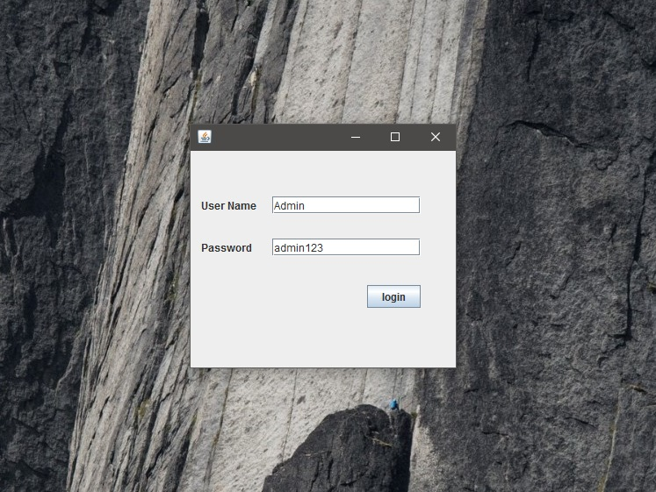
This is the part that is used by the administrator to update the database in terms of prices, Quantity of a product and the client does not have the privileges to login and change prices because the admin is only accessed through a login window

The Password field is case Sensitive so if the password doesn’t correspond with the admin name it will just return an error message specifying what it is that is typed wrong
once the password is correct a window will appear telling you that “welcome to the stock management system” then press OK to go into the management window to do some admin work in the database

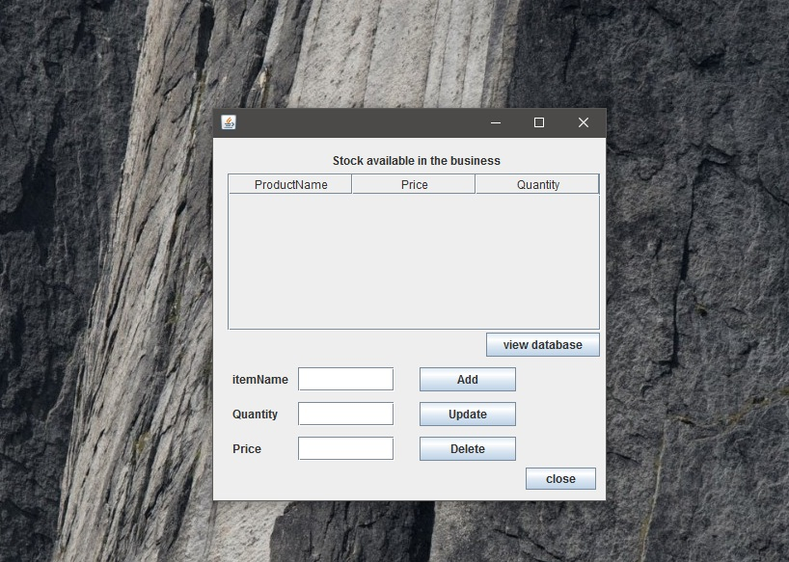
below is the management window, this window give the administrator the right to update, delete or add new product to the store

how do to check products available in the store’s database
Centre right there’s a button named “View database” clicking the button show the stock in the business and its quantity and these are products stored in the business’s database
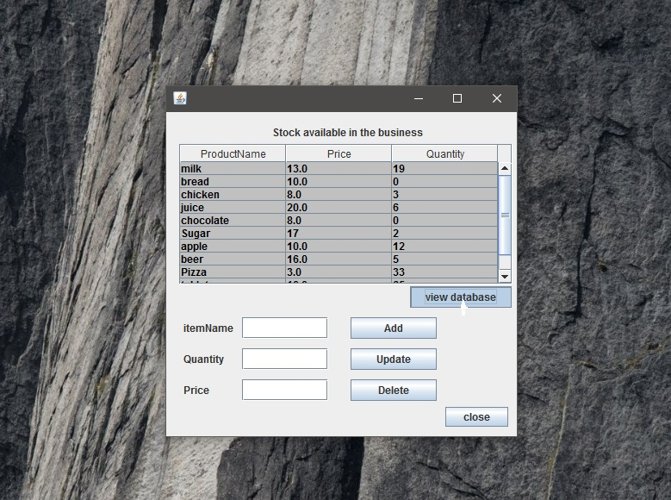

how to add products in the store

adding products to the store requires the administrator to input the name of product,
price and Quantity then press add button to add the product in the store’s database
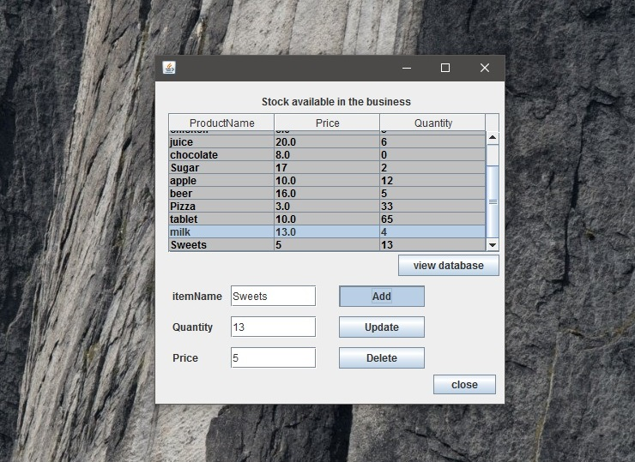
after adding it adds a row to show you that the product has been added to the

how to update products in the store

when updating products in the store you should be specific to what you want to update and by writing the name of the product on the text-field =” item Name” so that it knows what to update in the database and then specify the price and quantity that you want to change to
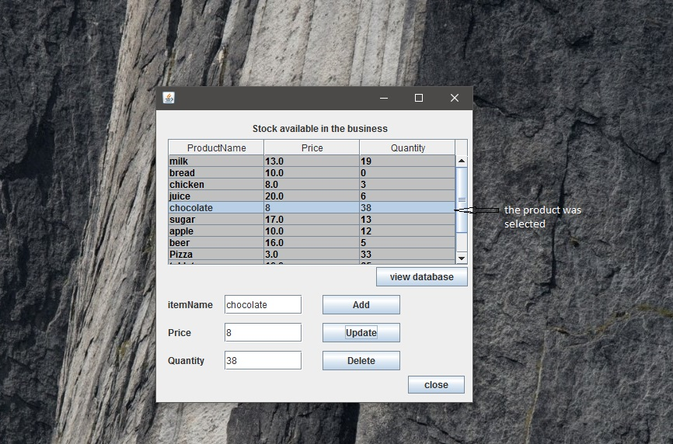

how to remove stock in the store
removing the product from the database/stores works similar like update
you should specify the name of the product in the correct text-field then
press delete, by pressing delete a message box will appear telling you that
the product has been removed

